**Steps to Use Your Own Machine to Host Shiny App**

07/15/2015, Dingchao Zhang

1. If your machine does not have xampp installed,please download and install xampp package for your operating system at here : <https://www.apachefriends.org/index.html>

Here is an Youtube walking though xampp installation for windows 8 and windows 8.1:

<https://www.youtube.com/watch?v=U5ghHLRv6uc>

1. Start apache server, if you see the following error about server shuts down unexpectedly, do the following steps in 2, otherwise skip this part and directly go to step 3.

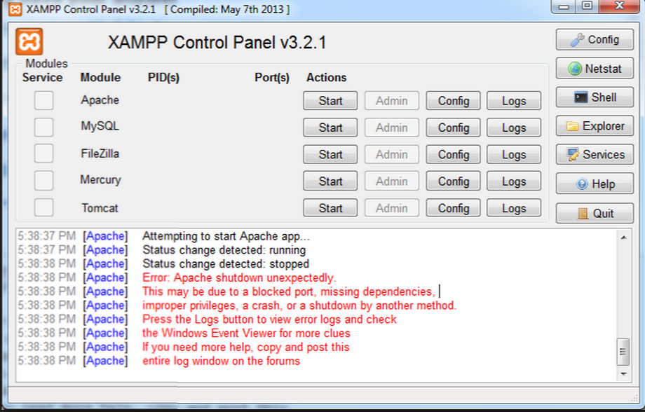

2.1 Please click Config button, open httpd.conf file

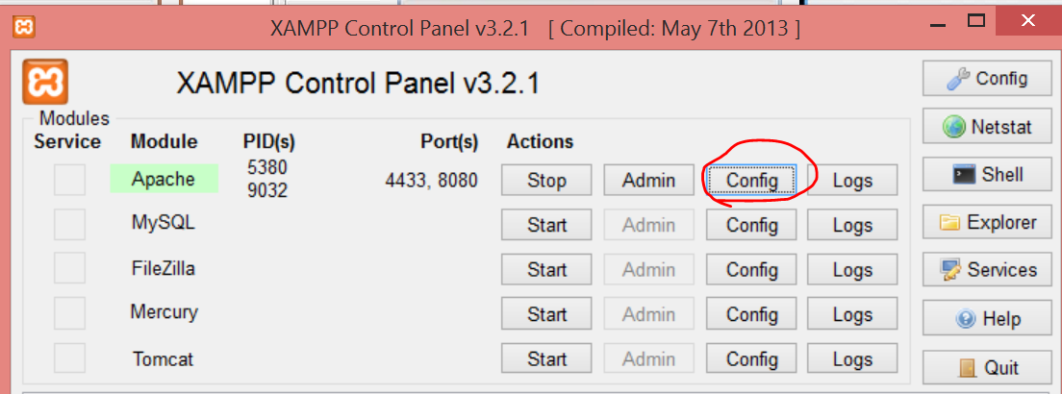

2.2 Modify all the places where it writes the port ID 80 to 8080 in httpd.conf

2.2.1 Specifically modify the Listen to specific IP addresses to 8080:

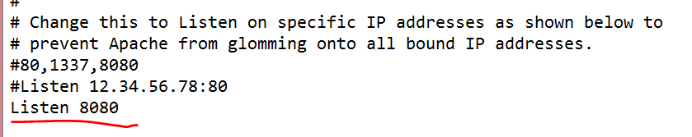

2.2.2 And specifically modify the ServerName Localhost to 8080

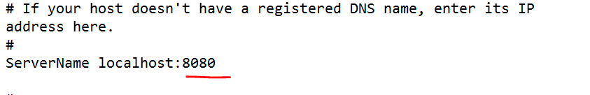

* + 1. Save the changes to httpd.conf

2.3 Please click Config button, open httpd-ssl.conf file

2.3.1 Modify all the places where it writes the port ID 443 to 4433 in httpd-ssl.conf

2.3.2 Specifically ensure to modify the Listen to specific HTTPs port to 4343:

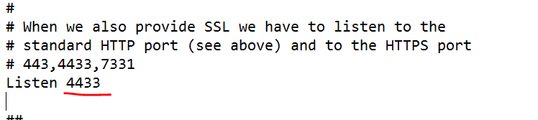

* + 1. Specifically ensure to modify the virtua host and servername port to 4343:

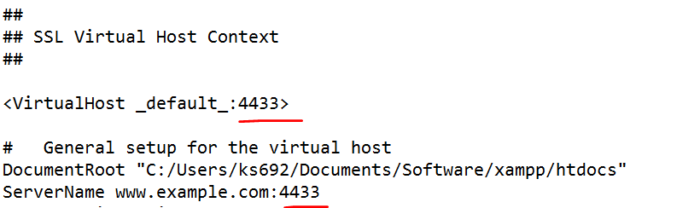

* 1. Save the changes to httpd-ssl.conf
  2. After all the above changes are saved, restart xampp, and start Apache server, and you shall see it is running at ports 4433 and 8080

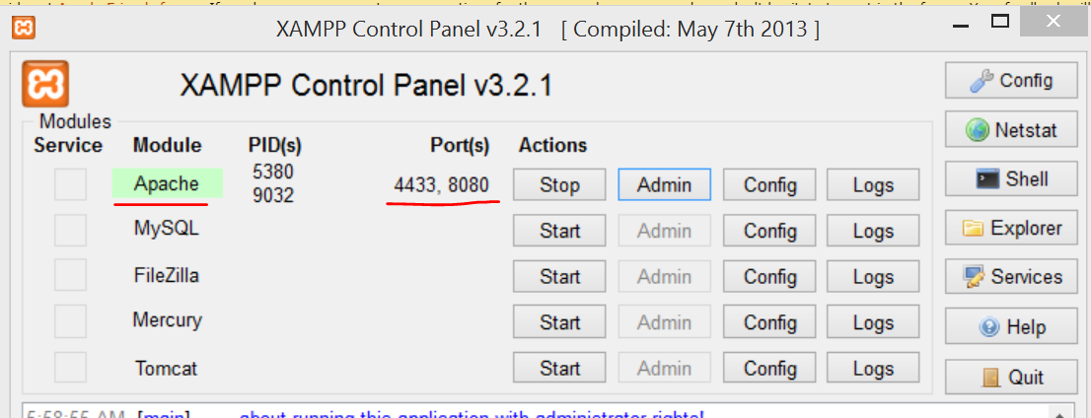

1. Please click Config button, open httpd-xampp.conf : comment out Require local , and add “Order deny, allow”, and “Allow from all “or Allow from ( certain IP addresses) before ErrorDocument 403 in the buttom of the file, which should be looking like the following:

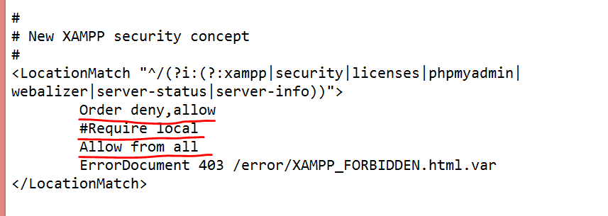

1. In R, run the following command to specifically make R listen to your IP address instead of default 127.0.0.1 the loopback IP, specify the port to 5410 or any other port that is not occupied by applications if you know.

runApp(appDir = '~/Dingchao/Courses/R/Shiny/shiny quick start/How-to-start-3/',port = 5410,host=getOption("shiny.host","10.129.108.1"))

More information about how to use runApp command in R can be found here:

<http://shiny.rstudio.com/reference/shiny/latest/runApp.html>

You can find your wirelss Ipv4 address by typing ipcofig in windows command line window:

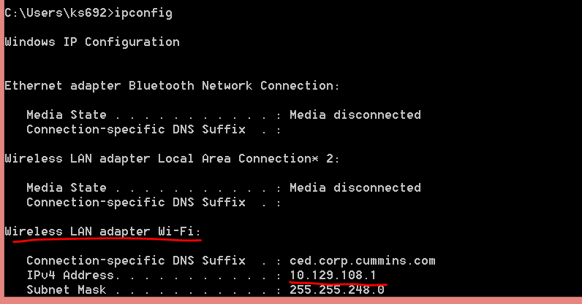

**Note** that if you switch from wifi to wired connection, or move your machine from one location to another( building to building, office to home, etc) , your IPv address might get changed.

1. Optional( set securty in xampp to ask an username and password) when access web for protection

The user name and password can be set at : localhost:8080/security/index.php via your browser.

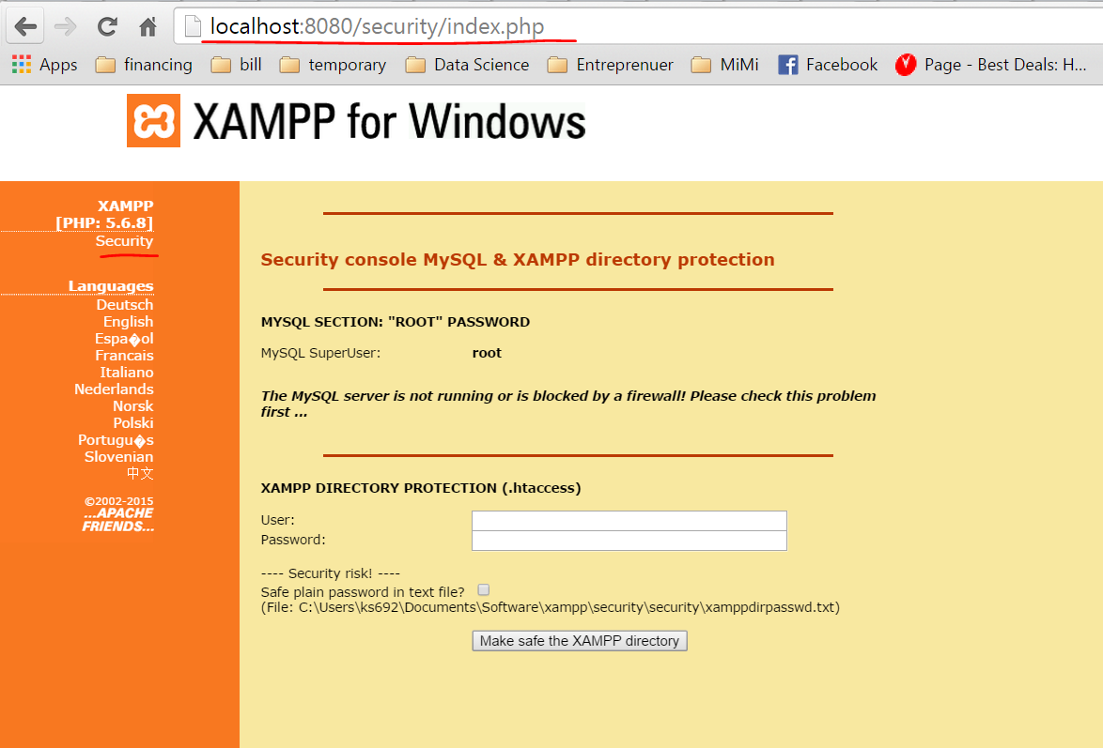

Note: If you didn’t change the port to listen at step 2, you may just type localhost/security/index.php in browser to view the above page

1. Clients can access the application by typing <http://10.129.108.1:5410/> in browser now

And you must keep Rstudio running so clients can access the above link, and your Rstudio shall be in the state of lisening on the following format <http://yourIPv4address:yourspecifiedport> , in the above example will be like the following:

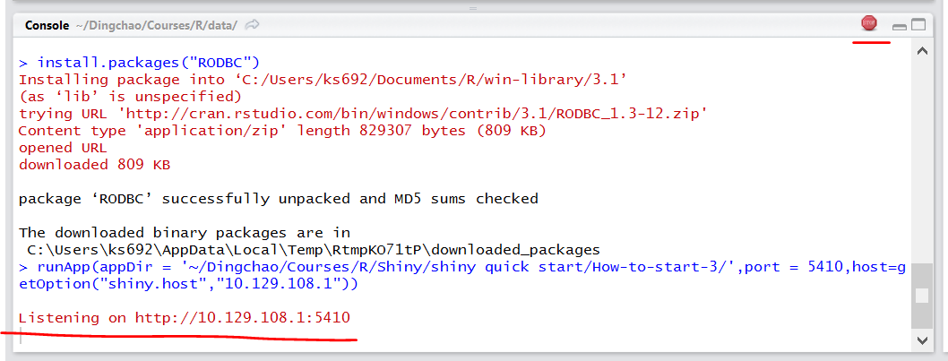

You may click the stop button to shut down the hosting.